INFO6210 Data Management and Database Design

Section 04

**App store Database**

**Xin Luo**

Introduction: 5

Cluster & Entity: 5

1. Application (Cluster): 5

1.1 Application (Entity): 5

Description 5

Purpose: 5

Business Rules: 5

Attributes: 6

Sample data: 6

Sample data: 7

1.2 Review: 8

Description: 8

Purpose: 8

Business Rules: 8

Attributes: 8

Sample data: 9

1.3 Category 10

Description: 10

Purpose: 10

Business Rules: 10

Attributes: 10

Sample data: 10

2. User (Cluster): 11

2.1 User (Entity): 11

Description: 11

Purpose: 11

Business Rules: 11

Attributes: 11

Example data: 12

2.2 Device 13

Description: 13

Purpose: 13

Business Rules: 13

Attributes: 13

Sample data: 13

2.3 Payment: 14

Description: 14

Purpose: 14

Business Rules: 14

Attributes: 14

Sample data: 15

2.4 Wish List: 16

Description: 16

Purpose: 16

Business Rules: 16

Attributes: 16

Sample data: 16

3. Download (Cluster): 17

Description: 17

Purpose: 17

Business Rules: 17

Attributes: 17

Sample data: 18

4. Developer (Cluster): 19

4.1 Developer: 19

Description: 19

Purpose: 19

Business Rules: 19

Attributes: 19

Sample data: 20

4.2 Developer Type: 21

Description: 21

Purpose: It is a bridge table to link Application and Developer together because of the many to many relationship. 21

Business Rules: 21

Attributes: 21

Sample data: 21

# Introduction:

An app store is a type of digital distribution platform for computer software, often in a mobile context. Apps provide a specific set of functions which, by definition, do not include the running of the computer itself. Apps are designed to run on specific devices, and are written for a specific operating system.

For the users, app store is a collections of application for users to download. User can not only download but also preview the application which they want to check. There are rating, user’s review and application description inside each application. This information can help users know properly about this app.

For the developers, app store is a good platform to show their application. They can check the users’ feedback to find the bug inside the application, then update properly to solve these problem.

# Cluster & Entity:

## Application (Cluster):

Application is a high level cluster which contains multiple different kinds of entities, like Application, Review and Category. These entities are all important components for application cluster.

### 1.1 Application (Entity):

Description: It’s a small, specialized program downloaded onto mobile devices.

Purpose: This table is to show the information and attributes for each application, which contain app name, category, author, images, version, price and introduction.

Business Rules: (IS - In Scope/OS – Out of Scope)

1. There is age limit for the download. Teenagers are not allowed to download which have some violent content. (IS)
2. User can’t copy the content from the application without any permission. (IS)
3. Users are not allowed to download the app without making a payment for the not free app. (OS)
4. Each application should have multiple categories. (IS)
5. Applications’ names are not allowed to be same. (IS)
6. An application should list specific operating system requirements. (IS)
7. An application listed in the app store must be the latest version. (IS)

#### Attributes:

|  |  |  |  |  |
| --- | --- | --- | --- | --- |
| **Attribute Name** | **Data Type** | **Key/Null** | **Definition** | **Example Data** |
| Application ID | Char (15) | PK NN | A series of unique number assigned by the system, which used to identify each application. | AAA001 |
| App Name | Varchar (20) | Unique NN | A unique name assigned by the developer. (IS-5) | Spotify |
| Version | Varchar (10) | NN | This is the attribute we use to classify the app. | 8.4.46 |
| Rating | Double | Null | The score shows how popular this app is, based on users’ feedback and evaluations. | 4.5(Up to 5.0) |
| Description | Varchar (200) | NN | A general description to introduce this application. | Spotify is the best way to listen to music on mobile. |
| Update | Varchar (300) | NN | Show the update information for the newest version | Bug fixes and various improvements. |
| Price | Money | NN | Show the price for the application. | 0 |
| Operating System Requirements | Varchar (20) | NN | The lowest operating system request to run this application. (IS-6) | iOS 11.3 |
| Developer ID | Char (15) | FK NN  Unique | A series of unique number assigned by the system, which used to identify each developer. | 001AAA |

#### Sample data:

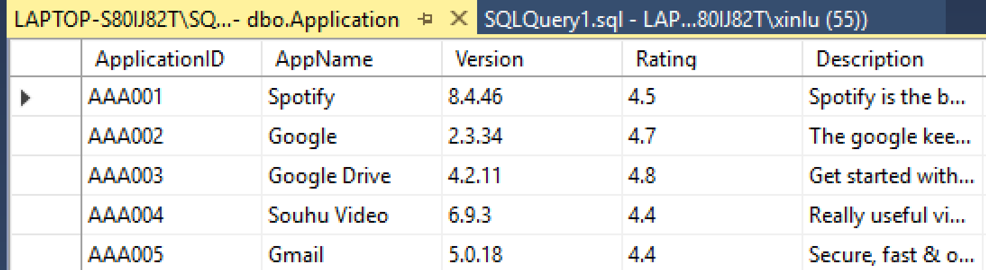

**App Information** (Sub table of Application):

|  |  |  |  |  |
| --- | --- | --- | --- | --- |
| **Attribute Name** | **Data Type** | **Key/Null** | **Definition** | **Example Data** |
| Information ID | Char (15) | PK NN | A series of unique number assigned by the system, which used to identify each application’s information. | AAA0011 |
| Application ID | Char (15) | PFK NN | A series of unique number assigned by the system, which used to identify each application. | AAA001 |
| Developer ID | Char (15) | Unique  NN | A series of unique number assigned by the system, which used to identify each developer. | 001AAA |
| Author Name | Varchar (20) | NN | The name of author for a specific application. | Spotify |
| Size | Double | NN | The memory of application occupied the amount of storage in user’s device. | 90.6MB |
| Language | Varchar (15) | NN | Show the price for the application. | English, Chinese |
| Age limit | Integer | Null | User’s lowest request for using this application. | >12 years old |
| In-app Purchase Items | Varchar (50) | Null | A list of items which user needs to pay for that service. | Monthly VIP |

#### Sample data:

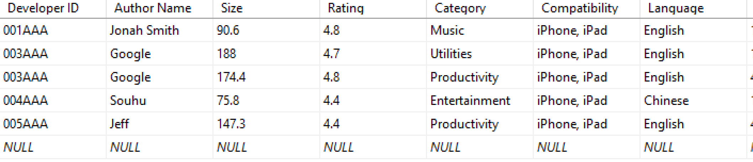

### 1.2 Review:

Description: Some comments which are written by users to describe their experiences after using the application.

Purpose: This entity is to show all the comme nts for each application.

Business Rules: (IS - In Scope/OS – Out of Scope)

1. Each review needs to limit the number of the word. (IS)
2. Not allowed to enter some dirty words or insulting languages. (IS)
3. One application can have multiple reviews. (IS)
4. Both users and developers can check the reviews. (OS)
5. Reviews can contain both active and negative reviews. (IS)
6. Developers are not allowed to submit the review. (OS)

#### Attributes:

|  |  |  |  |  |
| --- | --- | --- | --- | --- |
| **Attribute Name** | **Data Type** | **Key/Null** | **Definition** | **Example Data** |
| Review ID | Char (15) | PK NN | A series of unique number assigned by the system, which used to identify each user’s review | 10AA10 |
| User ID | Char (15) | PFK NN | A series of unique number assigned by the system, which used to identify each user | 10000A |
| Date | Date | NN | The time when you made a feedback | 08/09/2017 |
| Feedback | Varchar (300) | NN | This is what users write for this application which contains evaluations | As a music streaming app, it works great! |
| Application ID | Char (15) | FK NN | A series of unique number assigned by the system, which used to identify each application | AAA001 |

#### Sample data:

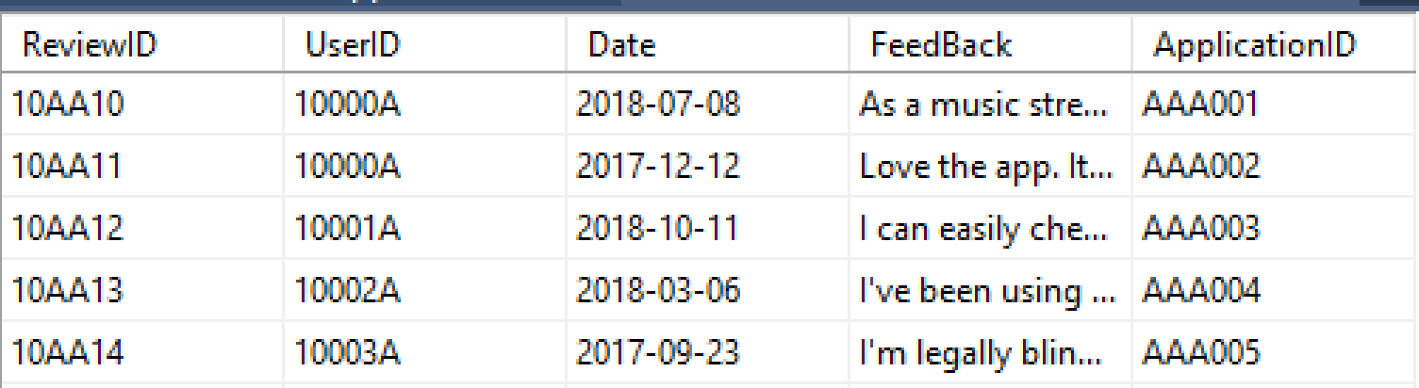

### 1.3 Category

Description: A list of all the categories which application has.

Purpose: Classifying the applications according to their content and functions.

Business Rules: (IS - In Scope/OS – Out of Scope)

1. One application can have multiple different categories. (IS)
2. Application can’t exist without category.

#### Attributes:

|  |  |  |  |  |
| --- | --- | --- | --- | --- |
| **Attribute Name** | **Data Type** | **Key/Null** | **Definition** | **Example Data** |
| Category ID | Char (15) | PK NN | A series of unique number assigned by the system, which used to identify different categories | 0AA12 |
| Application ID | Char (15) | PFK NN | To show which application did user download | AAA001 |
| Category Type | Varchar (10) | NN | The name for category | Entertainment |

#### Sample data:

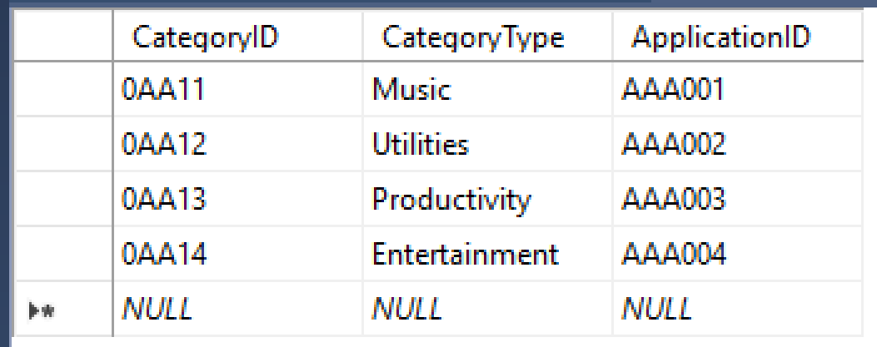

## User (Cluster):

The User cluster was created to save some personal information for users and document users’ behavior when they using app store. Inside this cluster, we have entities like User, Device, Payment and Wish List.

### 2.1 User (Entity):

Description: The person who has an account on app store and downloads and uses the application.

Purpose: Save and document user’s information and behavior.

Business Rules: (IS - In Scope/OS – Out of Scope)

1. Each user need to bind an account for payment when you register. (IS)
2. Each user need input some important personal information. (IS)
3. Each user can have multiple devices. (IS)
4. Password should be constrained within 8 digits and contains both letter and number. (IS)
5. User can download one application in different devices. (IS)
6. User is identified by User ID. (IS)
7. A user must have at least one payment method. (IS)

#### Attributes:

|  |  |  |  |  |
| --- | --- | --- | --- | --- |
| **Attribute Name** | **Data Type** | **Key/Null** | **Definition** | **Example Data** |
| User ID | Char (15) | PK NN | A series of unique number assigned by the system, which used to identify each user. | 10000A |
| User Name | Varcha (20) | NN | User’s full name. | Xin Luo |
| User Account | Varchar (20) | NN | User account’s name assigned by user. | Luo.xin1 |
| Password | Varchar (10) | NN | Password for user account. | Victory2017 |
| PhoneNum | int | Null | User’s phone number. | 617-2599-952 |
| Address | Varchar (30) | Null | User’s address. | 54 Calumet Street |

#### Example data:

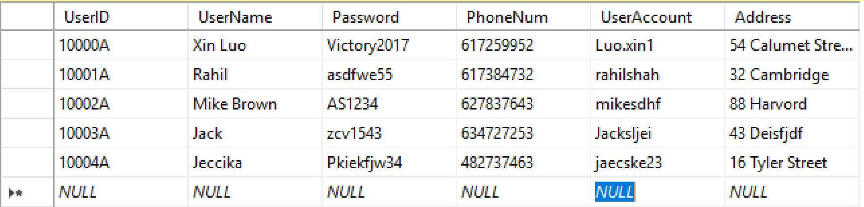

### 

### 2.2 Device

Description: The place where user download and execute the application.

Purpose: The function for this entity is to connect user and download together.

Business Rules: (IS - In Scope/OS – Out of Scope)

1. One user can have multiple devices. (IS)
2. User can download one application on different devices. (OS)

#### Attributes:

|  |  |  |  |  |
| --- | --- | --- | --- | --- |
| **Attribute Name** | **Data Type** | **Key/Null** | **Definition** | **Example Data** |
| Device ID | Char (15) | PK NN | A series of unique number assigned by the system, which used to identify each user’s device | 0AAA |
| Device Type | Varchar (10) | NN | Device’s name | iPhone 6 plus |
| User ID | Char (15) | FK NN | Defined the person who use this device | 10000A |

#### Sample data:

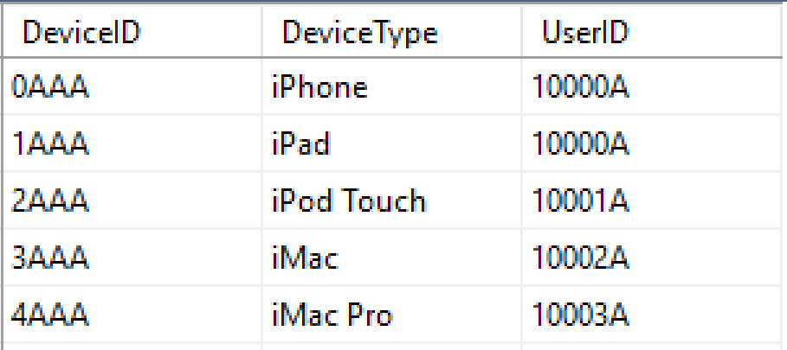

### 2.3 Payment:

Description: Transfer the money in order to get the permission for using the premium features for the app.

Purpose: In order to show the payment detail information, such as payment type, payment time, card information, application’s price

Business Rules: (IS - In Scope/OS – Out of Scope)

1. When binding the credit card or debit card, users are compulsory need to input their card detail like card number and date. (IS)
2. One payment can only contain one application. (IS)
3. Receipt is required for each payment. (IS)

#### Attributes:

|  |  |  |  |  |
| --- | --- | --- | --- | --- |
| **Attribute Name** | **Data Type** | **Key/Null** | **Definition** | **Example Data** |
| Payment ID | Char (15) | PK NN | A series of unique number assigned by the system, which used to identify each payment | A1000A |
| Bank Name | Varchar (20) | NN | The name for the bank which your payment belongs to | Bank of America |
| Payment Method | Varchar (10) | NN | The method you use to make a payment. | Debit card |
| User ID | Char (15) | FK NN | A series of unique number assigned by the system, which used to identify each user | 10000A |
| Device ID | Char (15) | FK NN | A series of unique number assigned by the system, which used to identify each user’s device | 0AAA |

#### Sample data:

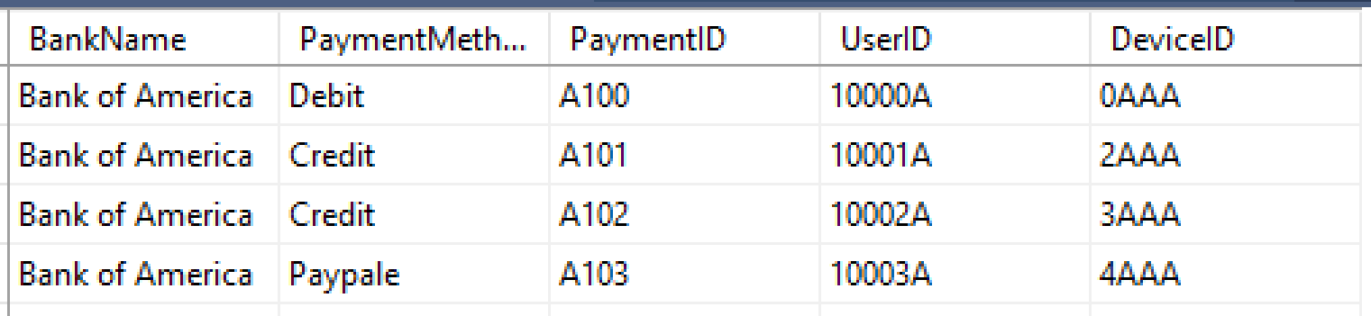

### 2.4 Wish List:

Description: It is the collection of applications which user want to download, same as shopping cart, user can save some application they like, most of them are not free, so they are waiting for a discount.

Purpose: Link the application and user together, then document all of applications what user want, notify them to make a payment.

Business Rules: (IS - In Scope/OS – Out of Scope)

1. User can’t add any application into the wish list without registering his account. (OS)
2. The version for the application inside the wish list need to update automatically when there is a new version updated. (IS)

#### Attributes:

|  |  |  |  |  |
| --- | --- | --- | --- | --- |
| **Attribute Name** | **Data Type** | **Key/Null** | **Definition** | **Example Data** |
| User ID | Char (15) | PFK NN | A series of unique number assigned by the system, which used to identify each user. | 10000A |
| Application ID | Char (15) | PFK NN | To show which application did user download | AAA001 |
| App Name | Varchar (20) | Unique NN | A unique name assigned by the developer. (IS-5) | Spotify |
| Version | Varchar (10) | NN | This is the attribute we use to classify the app. | 8.4.46 |

#### Sample data:

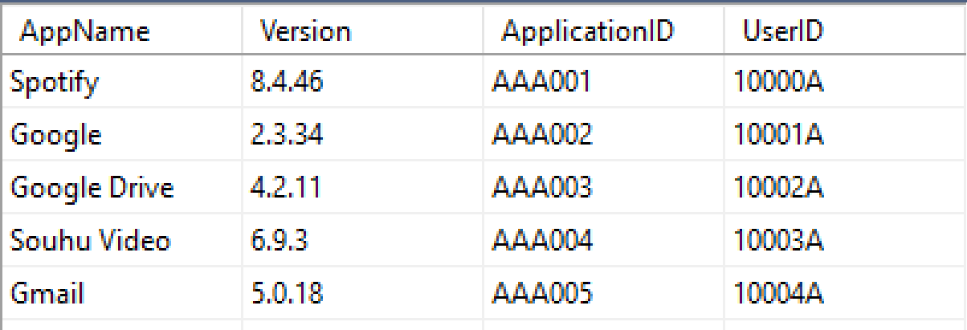

## Download (Cluster):

In Download cluster, we save some download information not only for users, but also for the applications. This cluster was created to link Application cluster and User cluster together.

Description: This entity shows all the applications which user has already downloaded.

Purpose: In order to document the user behavior when using app store .

Business Rules: (IS - In Scope/OS – Out of Scope)

1. Only downloaded application can appear in the download and help users to find the application which they deleted before. (IS)
2. Users no need to pay the application again if they deleted this application before. (OS)
3. Download an application must should have a device. (IS)
4. The lowest requirement for the operating system of the application should be same as user’s device operating system when making a download. (IS)

#### Attributes:

|  |  |  |  |  |
| --- | --- | --- | --- | --- |
| **Attribute Name** | **Data Type** | **Key/Null** | **Definition** | **Example Data** |
| Download ID | Char (15) | PK NN | A series of unique number assigned by the system, which used to identify each downloads | 10AA10 |
| Application ID | Char (15) | PFK NN | To show which application did user download | AAA001 |
| Device ID | Char (15) | PFK NN | A series of unique number assigned by the system, which used to identify each user’s device | 0AAA |
| App Name | Varchar (20) | Unique NN | A unique name assigned by the developer. (IS-5) | Spotify |
| Version | Varchar (10) | NN | The version number for this application when user downloaded. | 8.4.46 |
| Download Time | Date | NN | The time when user download the application | 08/09/2018 |
| Status | Varchar (10) | NN | Show the status for the application display on user’s devices. | Downloaded but deleted |
| Device Operating System | Varchar (20) | NN | Show the version of operating system for this device | iOS 11.3 |

#### Sample data:

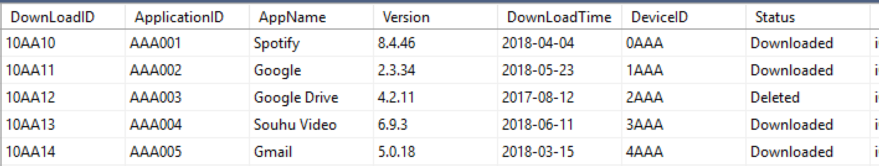

## Developer (Cluster):

This cluster was created to save all of the information for the developers like name, website and briefly introduction.

### 4.1 Developer:

Description: This entity shows the author information who create the application.

Purpose: Show some important developers’ information for users who want to know more about this developer.

Business Rules: (IS - In Scope/OS – Out of Scope)

1. One developer can have multiple applications. (IS)
2. A developer could only be a person or a company. (IS)

#### Attributes:

|  |  |  |  |  |
| --- | --- | --- | --- | --- |
| **Attribute Name** | **Data Type** | **Key/Null** | **Definition** | **Example Data** |
| Developer ID | Char (15) | PK NN | A series of unique number assigned by the system, which used to identify each developer | 001AAA |
| Official website | Varchar (30) | Null | Developer’s official website. | www.asd123.com |
| Developer Name | Varchar (30) | NN | Developer’s name | Jonah Smith |
| Developer Type | Varchar (10) | NN | The type of developer, company or private. | Private |
| Introduction | Varchar (200) | Null | A general introduction for this developer | Null |
| Type ID | Char (15) | FK NN | A series of unique number assigned by the system, which used to identify each developer type. | 100 |

#### Sample data:

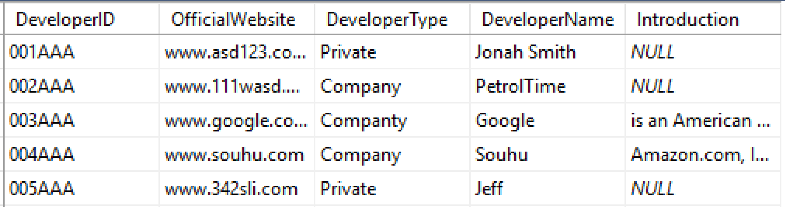

### 4.2 Developer Type:

Description: This entity shows the different kinds of developer types.

Purpose: It is a bridge table to link Application and Developer together because of the many to many relationship.

Business Rules: (IS - In Scope/OS – Out of Scope)

1. One developer could only have one type. (IS)

#### Attributes:

|  |  |  |  |  |
| --- | --- | --- | --- | --- |
| **Attribute Name** | **Data Type** | **Key/Null** | **Definition** | **Example Data** |
| Type ID | Char (15) | PK NN | A series of unique number assigned by the system, which used to identify each developer type. | 100 |
| Type Name | Varchar (20) | NN | The type of developer, company or private. | Private. |

#### Sample data:

